

Detection of AI-Generated Arabic Text
Haneen Alahmadi
MSIS-822 Advanced Data Analytic Techniques, Department of Information Systems, College of Computer Science and Engineering, Taibah University, Saudi Arabia, tu4725055@taibahu.edu.sa
Instructor: Dr. Mohammed Al-Sarem

Abstract: The rapid advancement of Large Language Models (LLMs) enabled the generation of accurate, fluent, and coherent Arabic text, which is a significant challenge to distinguish between human-written and AI-generated Arabic text. This study aims to detect AI-generated Arabic text for achieving academic integrity and preventing misinformation. This study proposes a binary classification approach to detect AI-generated Arabic text by applying six models, three of which are machine learning classifiers (SVM, XGBoost) with feature engineering and a logistic regression classifier, and three of which are transformer-based models, AraBERT, CAMeL-BERT-MIX, and AraELECTRA, where AraELECTRA achieved the best performance across all evaluation metrics with an accuracy of 0.99 and an F1 of 0.96.
Keywords: Large Language Models, Arabic Natural Language Processing, AI-Generated Text Detection.

1. Introduction
The revolution in Artificial Intelligence (AI) and its fields, such as Large Language Models (LLMs), brought a qualitative leap in Natural Language Processing (NLP). At present, the machine is proficient at simulating human-written text, producing fluent, coherent, and contextually correct text. That led to flourishing in written content in sectors such as education, news, and social media text. However, one of its drawbacks is that it produces misleading text and compromises academic integrity. With the development of LLM and the growing usage of LLM, the distinction between human-written and AI-generated text is extremely difficult. [1] [2]

1.1 Problem Definition
This study aims to distinguish AI-generated Arabic text from human-written text with high accuracy. Arabic text represents a challenge due to its complex morphology and the difficulty of writing it. The rapid advancement of LLM has made the traditional text classification techniques less efficient in addressing this challenge. [3]

1.2 Project Objectives
The objectives of this project are to build a robust binary classification system for the detection of AI-generated Arabic text by building Machine learning models (ML) with baseline models such as Logistic Regression and performing feature engineering for SVM and XGBoost models, transformer-based models used in this project, with three models such as AraBERT, CAMeL-BERT-MIX, and AraELECTRA, and evaluating models' performance with evaluation metrics to grant reliable and effective performance of models, which are Accuracy, Precision, Recall, F1-score, and ROC-AUC. [4]

1.3 Motivation
The motivation for this study is to develop a system for the detection of AI-generated Arabic text, a system that matches the robustness of systems for detecting AI-generated English text, thereby enabling the detection of plagiarism and misinformation in Arabic fields to achieve academic integrity and trustworthiness. [2] [5]

2. Related Work

2.1 AI-Text Detection Approaches
Early studies on AI-text detection as historical classification are based on four traditional categories: classifiers trained from scratch, zero-shot classifiers, fine-tuning of large neural models, and human-machine collaboration. With the advent of ChatGPT, the LLM-generated text domain has experienced a qualitative leap, transforming research directions to address LLM-text detection challenges. [6]
In contrast, recent studies on AI-text detection have categorized them into five categories: watermarking, feature-based, neural-based, hybrid, and human-aided approaches. Those approaches detect LLM-generated texts and limit the risk of growing AI-generated text. LLM accurately simulates human writing, thus making it difficult to distinguish between LLM-generated text and human-written text. Among the five approaches, emphasize feature-based methods that detect AI-generated text by using measures such as grammar, syntax, and stylistic patterns to distinguish it from human-written text. [7]

2.2 Arabic AI-Text Detection Studies
The recent studies have focused on AI-generated text detectors in Arabic, considering that the field still suffers from weaknesses in tackling the rise of ChatGPT and requires more development in AI detectors for Arabic text, which represents a challenge due to the difficulty of the Arabic language. This study [8] introduces a classifier designed for Arabic AI detector text by using AraELECTRA and XLM-R fine-tuning transformer models on diacritized and undiacritized data. This study indicates that GPTZero and OpenAI detectors have poor performance in detecting Arabic AI-generated text. Additionally, the study presents essential results, showing that integrating a Dediacritization layer improves accuracy to 99% and, in some cases, 100%. These results reinforce that AI-generated text detectors in Arabic are still lacking in the presence of specialized architecture and the recent studies' gap in designing and building robust detectors for Arabic in comparison with English detectors.

2.3 Gaps in Literature
Although significant advancements in AI-generated text detection have occurred, the rapid development of LLMs confronts human writing professionally, which constitutes a substantial gap in current detectors. The essential gaps from previous studies: Weakness of AI detectors in Arabic text in contrast to AI detectors in English text, which have robustness. That led to a lack of Arabic AI detectors due to challenges in the Arabic language, such as root-based morphology and complex grammar. Abandon Feature Engineering: despite the progress of transformers in AI detectors, it is necessary to use feature engineering to address issues such as adversarial attacks and out-of-distribution. Feature engineering leverages statistical and linguistic features to overcome challenges that arise when using only deep learning AI detectors. This research intends to close the gaps by developing a robust detector for AI-generated Arabic text through the use of robust feature engineering with machine learning and transformer architecture.

3. Dataset Description

3.1 Dataset Source
The dataset used in this research is the KFUPK-JRCAI Arabic-generated abstracts dataset, publicly available on Hugging Face. The dataset provides a significant step forward in the domain of Arabic AI-generated text to support researchers in producing studies in AI detection and stylometric analysis, etc., in Arabic AI text.

3.2 Dataset Structure
The dataset is grouped into three AI structures based on the methods used to generate them.

3.2.1 AI-generated text
- by_polishing: refines existing human abstracts by AI models.
- from_title: AI models were generated from full abstracts of paper titles.
- from_title_and_content: AI models were generated from the full abstract of the paper title and content.

3.2.2 Data Fields
Each sample in the dataset contains:
Filed Name | Description
original_abstract | Human-written abstract
allam_generated_abstract | allam -generated abstract
jais_ generated_abstract | jais -generated abstract
llama_ generated_abstract | llama -generated abstract
openai_generated_abstract | openai -generated abstract
Table 1: Data Fields per Sample

In this research, the four AI-generated abstract classes have been merged into one class, the AI class, and the original_abstract class into the Human class to obtain binary classification.

3.3 Final Dataset Size

The new dataset structure contains two columns: the first, “text”, contains the abstracts, and the second, “label”, contains either “human” or “ai”. The new dataset used in this study includes 41,940 samples for both labels.

3.4 Class Distribution

The final dataset is significantly imbalanced, 33,552 samples for the “ai” label and 8388 samples for the “human” label, as shown in Figure 1.
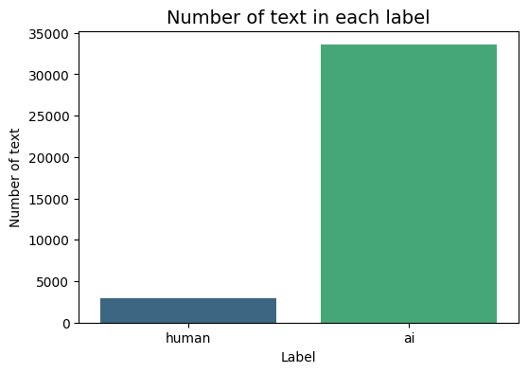
Figure 1: Distribution of labels

3.5 Challenges in the Dataset

3.5.1 Class Imbalance Challenges
The final dataset contains 33552 samples for the “ai” class, which is represented as 80% of the class label, making the “ai” class dominant over its counterpart, the “human” class, which is defined as 20%. The imbalance in predicting the result is biased toward the “ai” label.

3.5.2 Duplicate Samples Challenges
The final dataset contains 5,399 duplicated rows. As shown in Table 2, the human label includes 8388, and 5396 of them are replicated, thus the total number of unique samples is equal to 2,989 in the human label compared with 33,549 samples in the ai label.
label | Duplicates_count
ai | 3
human | 5396
Table 2: Duplicates for each label

4. Methodology

4.1 Preprocessing Pipeline
The preprocessing step is the core of Arabic Natural Language Processing (ANLP) due to the difficulty of Arabic text, including rich morphology, complex grammar, and diacritics. [3] The preprocessing significance lies in reducing noise and orthographic variability to ensure proper preparation of the dataset for machine learning and the transformer, yielding robust and accurate results. The following preprocessing workflows were applied in this study:

4.1.1 Normalization of Arabic Text
Normalization is standardizing the Arabic text into standard form. [3] Applied the following rules:
- Replacing the following character:
- [أ،إ،آ،ا] by [ا]
- [ى] by [ي]
- [ؤ] by [و]
- [ئ] by [ي]
- [ة] by [ه]
Such as the word “importance” in Arabic “أهمية” after Normalization will be “اهميه”.
- Removing Longation:
For example, the word “excellent” in Arabic “ممتااااز” after removing longation will be “ممتاز”.
- Removing Spaces:
Remove any extra space between the words or at the front/end of the phrases.
- Removing Diacritics:
Removes Arabic diacritics, including shadda, fatha, damma, kasra, tanwin, sukun, and kashida. For example, the greetings assalamu alaikum in Arabic “السَّلامُ عَلَيْكُم” after removing diacritics will be “السلام عليكم”.

4.1.2 Removing Arabic Stop Words
Arabic text contains frequent words that are meaningless, such as “في”,”هذا”,”من”. Removing stop words helps the models to reduce noise and improve efficiency. [3]

4.1.3 Stemming
Stemming is a process that returns words to their morphological root, such as “الدراسات” to “درس”. Stemming is useful for improving retrieval tasks in machine learning. [3]

4.1.4 Removing Duplication

The original dataset includes 5,399 duplicated samples, which violates data integrity, affecting model accuracy, causing overfitting, and data leakage. Duplicated samples could bias neural network models because these models memorize repeated samples rather than learn generalizable behavior. As described in [9], data leakage can lead to unrealistically high performance of test samples. This aligns with observed deep neural model performance before removing duplicate rows, which yielded misleadingly high accuracy results.

4.2 Feature Engineering

The feature engineering is an essential stage for providing more insights to ML models, which leads to improved accuracy. This study proposed five distinct features between stylometric and sentiment analysis. This reflected improvement in the quality of the ML classifier for distinguishing between human-written and AI-generated Arabic texts. The five features are extracted from the dataset, specifically designed for the feature engineering phase to obtain accurate results, including all data preprocessing stages except for the following: removing special characters, semicolons, and stop words, and applying stemming.

4.2.1 Special Characters Ratio
As mentioned in [10], special characters, which are considered stylometric features, provide a distinguishing measurable writing style between AI-generated and human text. Special characters are non-alphanumeric characters such as (@,#,’,;,:,-,+,!,$). The function “specialCharRatio” is used to calculate special characters by using the following Equation 1.
$$\frac{Number of Special Characters}{Total Number of Characters}=Special Characters Ratio$$
Equation 1:Special Characters Ratio

4.2.2 Number of Semicolons
Demonstrated study [11] effectiveness measures semicolons as significant stylistic features between punctuation features as the third rank of seven discriminative features to detect AI-generated text from human text.

4.2.3 Number of Prepositions
The number of prepositions is a linguistic feature to detect AI-generated text from human text, such as ["متى","حاشا","ك","مذ","منذ","عدا","مع","من", "إلى", "على", "في", "عن", "ب", "ل", "حتى"] to capture critical information about the frequency of prepositions used as a stylometric feature.

4.2.4 Second Person Usage
The second-person pronouns are used to call the person you are speaking to, such as ["أنت ", "أنتم", "أنتما", "أنتن", "تقول]. This study proposed second-person pronouns as a measurable stylistic feature for distinguishing patterns between AI-generated and human-written Arabic texts.

4.2.5 Emotional Valence Score
The emotional valence score is polarity sentiment analysis: positive, neutral, or negative. [12] A key strength of sentiment analysis is measuring emotional tone and intensity, as presented in this study using the “emotionalValenceScore” function, which presents a dictionary of Arabic words that provides positive, negative, and neutral, then calculates a valence score based on each category as presented in Equation 2.
$$Valence\left(T\right)=\frac{1}{|T|}*\sum_{w∈T}{s\left(w\right)}$$
$$s\left(w\right)=\left\{\begin{aligned}+1 if w is a positive word \\ -1 if w is a negative word \\ 0 if w is a neutral word\end{aligned}\right.$$

Equation 2: Emotional Valence Score

4.2.6 Feature Standardization
To standardize the magnitudes of engineered numeric features to prevent one feature from dominating others and keep them on the same scale, which is an essential step for ML models used in this study, such as SVM and XGBoost, to limit bias from large-valued features. Scikit-learn provides StandardScaler. Standardization transforms the numeric feature to have a mean of zero and a standard deviation of 1. To ensure data integrity and avoid data leakage, StandardScaler was applied only to the training set, then to the validation and test sets. This pipeline follows the ML preprocessing as implemented in [13].

4.3 Train-Validation-Test Split
Splitting the data is critical for ML and DL models to avoid overfitting by tuning hyperparameters and ensuring unbiased evaluation on using a hidden part of the dataset for testing. The splitting approach used in this study is 70% for the training set, 15% for validation, and 15% for testing. As demonstrated by [14], differences in data splitting methods are reflected in model performance. The study shows cross-validation stable performance, while train–validation–test is sensitive to overfitting. In this study, the approach used train–validation–test instead of cross-validation due to the dataset exceeding 40,000 samples. Therefore, applying cross-validation on this dataset will be time consuming and computationally expensive because of the preprocessing and feature engineering stages. The validation set provides stable performance without concern for overfitting.

4.4 Models Used

4.4.1 TF-IDF Vector Representation
The dataset used in this study is textual; traditional ML models only accept input numerical vectors. This study used Term Frequency-Inverse Document Frequency (TF-IDF) representation to transform the textual dataset into a high-dimensional sparse vector. TF-IDF measures the importance of a frequent term in a document, but it is rarely used across the corpus, which is reflected in the ML's classification performance. [15] In this study, TF-IDF features were implemented using the TfidfVectorizer module from the Scikit-learn library, which performs tokenization and n-gram generation internally. [13]

4.4.2 Handling Class Imbalance
Since the dataset suffers from a significant imbalance in labels between human-written and AI-generated Arabic text, as shown in Figure 1. To avoid of bias toward “ai” class and ensure fair training for the two classes across all the models, a class imbalance handling approach was applied in this study as presented in [16].
For traditional ML, such as Logistic Regression and SVM, class imbalance is handled through the class_weight='balanced' option in the ML model from Scikit-learn, which automatically modifies class weight according to the inverse of class frequency.
In the XGBoost model, class imbalance was handled through setting the scale_pos_weight parameter, which reweights the loss function gradients to focus on the class label with the least frequency during training.
For transformer-based models such as AraBERT, CAMeL-BERT, and AraELECTRA, class imbalance was handled by the cross-entropy loss function during fine-tuning. Calculated the class weights based on inverse class frequency, then integrated them into the loss function to prevent the transformer models from preferring the most frequent class.

4.4.3 Logistic Regression (Baseline Model)
Logistic Regression (LR) is an ML model used in this study as a baseline classifier according to simplicity and effectiveness in the classification tasks. The LR model was trained on the TF-IDF of the preprocessing dataset. The LR is considered a strong baseline for evaluating the relative performance gains of more complex models. [17]

4.4.4 Support Vector Machine (SVM)
Support Vector Machine (SVM) is used as a traditional machine learning model for classification tasks to detect AI-generated Arabic text and human text due to its robustness in dimensionality and sparse feature spaces. [18] SVM was used in this study as a classifier transformer to TF-IDF vectors merged with the five engineered features.

4.4.5 XGBoost
XGBoost (Extreme Gradient Boosting), an ensemble model based on gradient boosting decision trees, was employed in this study as a binary classifier to distinguish between human-written and AI-generated Arabic text. XGBoost was trained on a hybrid feature from TF-IDF vectors with engineered features similar to an SVM classifier. [19]

4.4.6 Transformer-based models
In this study, three deep learning models, as presented in (4.4.6.1 AraBERT, 4.4.6.2 CAMeL-BERT-MIX, 4.4.6.3 AraELECTRA), were fine-tuned to distinguish between human-written and AI-generated Arabic text using a supervised learning approach. Transformer models were trained for preprocessing the dataset without removing stop words or performing stemming, as they rely on the full context of the sentence. Pre-trained weights for the three Arabic transformer models were added, and a sequence classification layer was added to map binary class labels. Tokenization is used to convert the texts into numerical representations by padding and truncating to a maximum sequence length of 256. AS presented in section 4.4.2 Handling Class Imbalance, the cross-entropy loss function for computing class weight based on inverse class. Fine-tuning was performed for AraBERT, CAMeL-BERT-MIX, and AraELECTRA by using a custom trainer with a learning rate of 2e-5 for four epochs and an eight-batch size.

4.4.6.1 AraBERT
AraBERT is a transformer-based language model based on pre-trained BERT, especially for the Arabic language. In this study, AraBERT was used as a fine-tuning model to detect AI-generated or human-written Arabic text. [20]

4.4.6.2 CAMeL-BERT-MIX
CAMeL-BERT-MIX is an Arabic BERT model, it is a robust model trained on both modern Standard Arabic and dialectal variations. [21]

4.4.6.3 AraELECTRA
AraELECTRA is a self-supervised language representation learning. Unlike BERT, AraELECTRA does not predict masked tokens but learns to distinguish between original and replaced tokens. [22]

4.4.5 The Model Workflow

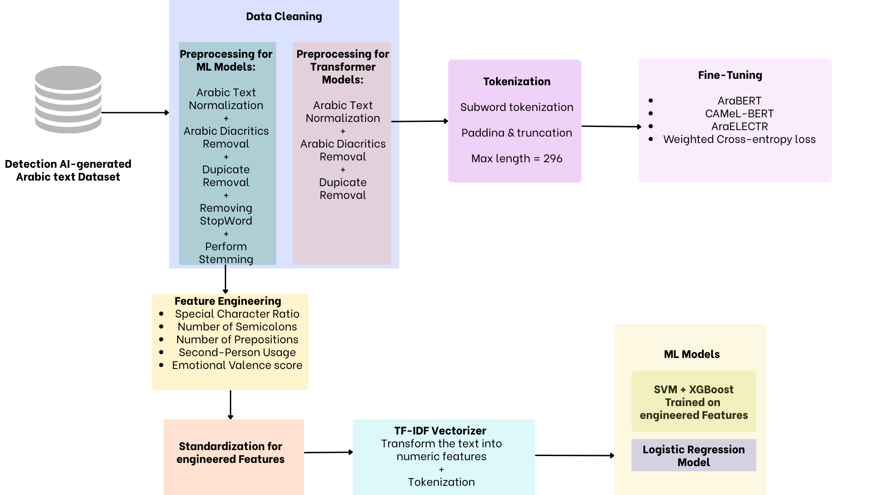
Figure 2 Model WorkFlow

5. Results & Analysis

5.1 Evaluation Metrics
To guarantee a comprehensive and reliable evaluation for all six models, this study used five approved criteria for model evaluation, which are Accuracy, Precision, Recall, F1-score, and ROC-AUC. For each metric used for model validation, such as Accuracy, it is unreliable for misleading in imbalanced classification tasks; therefore, other metrics were added to verify the results. Table 3 summarizes the model's performance based on the five evaluation metrics. The result shows a significant gap between machine learning models and transformer-based models. Among all six models, AraELECTRA achieved the best overall performance based on the following results: highest Accuracy (0.9936), F1-score (0.9609), and ROC-AUC (0.9989). Also, the AraBERT model achieves high performance as the second-best model with an F1-score of 0.9562 and an ROC-AUC of 0.9971. At the same time, the CAMeL-Mix model demonstrated robust performance with Recall (0.9510), which means strong sensitivity for AI-generated Arabic text. On the other side, ML models achieved good performance, but the best ML model was XGBoost. Overall, the high result of ROC-AUC, as shown in the following, demonstrates the effectiveness of the six models to distinguish between human-written and AI-generated Arabic Text. [4]
Model | Accuracy | Precision | Recall | F1 | ROC-AUC
AraELECTRA | 0.994 | 0.964 | 0.958 | 0.961 | 0.999
AraBERT | 0.993 | 0.964 | 0.949 | 0.956 | 0.997
CAMeL-Mix | 0.991 | 0.941 | 0.951 | 0.946 | 0.998
XGBoost | 0.973 | 0.846 | 0.820 | 0.833 | 0.989
SVM | 0.970 | 0.778 | 0.884 | 0.828 | 0.989
Logistic Regression | 0.954 | 0.652 | 0.947 | 0.772 | 0.987
Table 3:Model Comparison
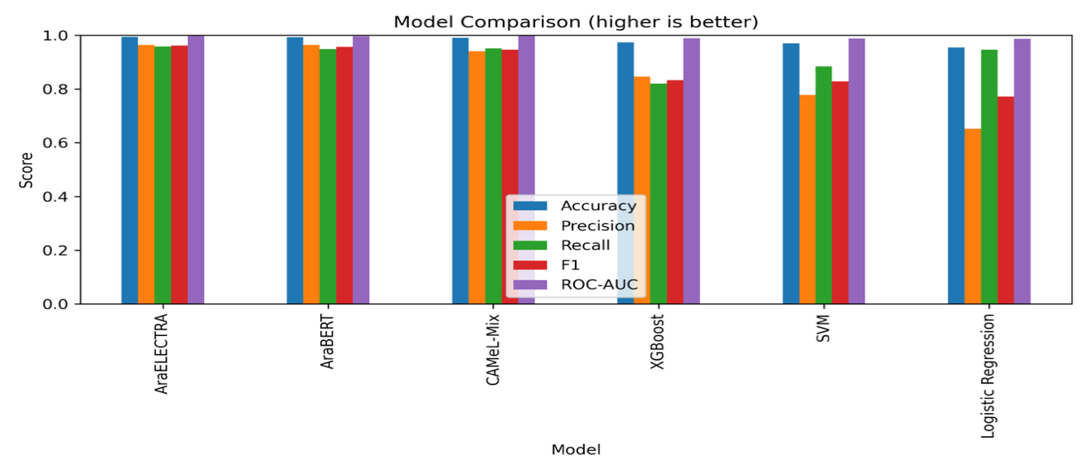
Figure 3:Model Comparison

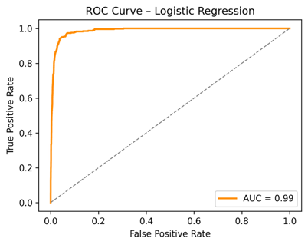
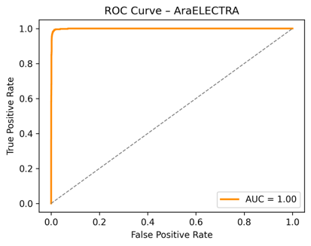 | 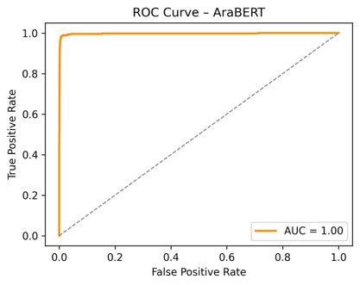 | 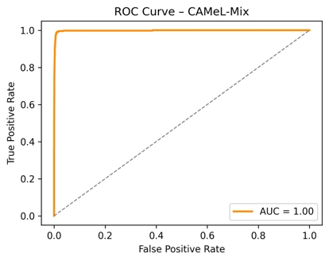
Figure 4 ROC-AUC

5.2 Confusion Matrices
Confusion Matrices are used as support for numerical metrics for the six models, as illustrated in the Figure 5. Confusion Matrices provide details about classification errors as a visualization for true positives, true negatives, false positives, and false negatives. [4] As shown in the Confusion matrix figures, AraELECTRA and AraBERT have the least misclassifications overall between the six models. AraELECTRA demonstrated robust performance with stable classification behavior and the best model with minimal confusion between classes. Based on the Confusion Matrices, AraELECTRA ranks first, and AraBERT ranks second because it has slightly higher misclassification classes than AraELECTRA, and CAMeL-Mix ranks third, with an increase in confusion between AI-generated and human-written Arabic text. XGBoost ranks fourth, and SVM ranks fifth, and the last model is LR. In contrast, XGBoost and SVM depend on statistical features instead of capturing semantic and stylistic patterns between AI-generated text and human Arabic text compared to transformer-based results. Overall, the confusion matrix analysis produces robust and stable performance and interpretable classification behavior between AI text and human text, especially in minimizing critical misclassification errors.

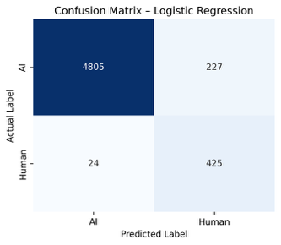 | 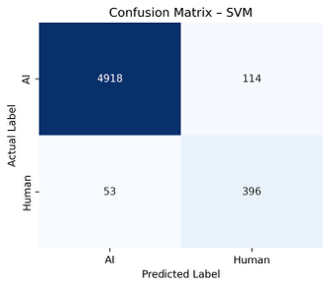 | 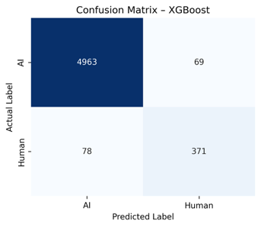
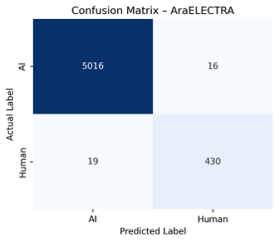 | 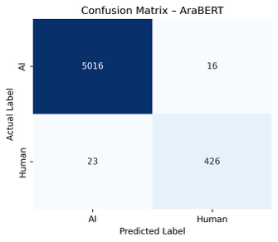 | 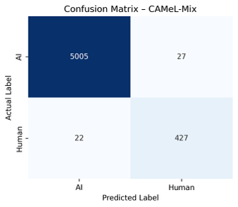
Figure 5:Confusion Matrices

5.3 Feature Importance

Feature importance analysis is performed to detect which features have the most effect on the XGBoost model to distinguish AI-generated Arabic text from human-written text. As shown in Figure 6, the most significant features are lexical and stylistic, and the semicolon frequency feature, which is extracted from the dataset.
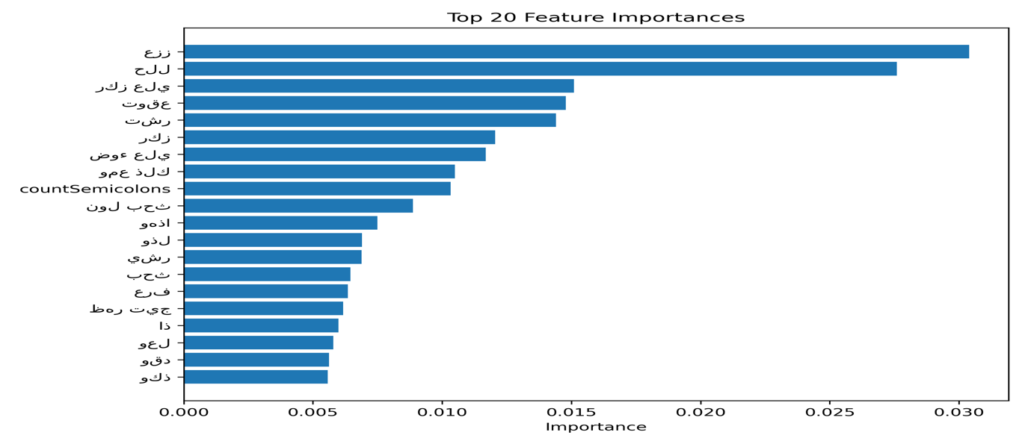

Figure 6: Top Feature Importance

5.4 Error Analysis
Error analysis detected that most of the misclassifications for the text happened when the AI-generated text was similar to a human writing style. In traditional machine learning models, false positives were more frequent, especially in the LR model, which classifies human-written text as AI-generated text. Transformer-based models were stable and provided reliable predictions with the least errors, which indicates robustness to detect semantic and stylistic style.

6. Conclusion & Future Work

6.1 Summary of Findings
This study addressed the challenge of distinguishing AI-generated Arabic text from human-written text by providing six models with different approaches, proposing a binary classification system. Three of them are ML, such as SVM and XGBoost, with engineered features, and presented logistic regression as a baseline ML model. XGBoost is the best traditional model with an accuracy of 0.97 and an F1 of 0.83, which reflects the benefit behind engineered features. On the other hand, the three transformer-based models used in this study, which are AraELECTRA, AraBERT, and CAMeL-Mix, outperformed significantly on ML models, providing overall performance and robustness. In particular, AraELECTRA was the best model over all evaluation metrics, such as an accuracy of 0.99 and an F1 of 0.96. This study achieves a crucial step in the Arabic NLP field, due to the difficulty of preprocessing in Arabic text; however, all the models' evaluation results proposed in this study were high, and it is a promising point that opens avenues for future researchers in the detection of AI-generated Arabic text.

6.2 Project Limitations

Despite the promising results, this study has a limitation in the dataset. The dataset suffers from duplicate and imbalanced samples; both problems are related to human labels, only 2,989 human labels compared to 33,549 after removing the 5,399 duplicated rows, which are reflected in the data's accuracy. Also, the dataset is limited to specific sources of writing styles; these limitations degrade data quality, which in turn is reflected in the model's performance.

6.3 Future Enhancements
Future work can extend this research by adding more engineered futures, as reflected in XGBoost performance, and by scaling up datasets to include a wider range of Arabic dialects and to add a balanced dataset to achieve higher model performance.

References

[1] | T. Brown, B. Mann, N. Ryder, M. Subbiah, J. Kaplan and e. al., "Language models are few-shot learners," in Advances in Neural Information Processing Systems (NeurIPS), 2020.
[2] | A. Uchendu, T. Le, Y. Zhang and D. Lee, "TuringBench: A benchmark environment for probing the detection of machine-generated text," in Proceedings of the 59th Annual Meeting of the Association for Computational Linguistics (ACL), 2021.
[3] | A. A. Nafea, M. S. Muayad, R. R. M. Ashour Ali, O. M. Bashaddadh, M. A. Khalaf, A. B. N. Sami and A. Steiti, "A Brief Review on Preprocessing Text in Arabic Language Dataset: Techniques and Challenges," Babylonian Journal of Artificial Intelligence, vol. 2024, no. 46–53, 2024.
[4] | D. M. W. Powers, "Evaluation: From precision, recall and F-measure to ROC, informedness, markedness and correlation," Journal of Machine Learning Technologies , vol. 2 , no. 1 , pp. 37-63 , 2011 .
[5] | M. S. Al-Shaibani and M. Ahmed, "The Arabic AI fingerprint: Stylometric analysis and detection of large language models text," 2023 .
[6] | J. Wu, S. Yang, R. Zhan, Y. Yuan, L. S. Chao and D. F. Wong, "A Survey on LLM-Generated Text Detection: Necessity, Methods, and Future Directions," Computational Linguistics, vol. 51, no. 1, p. 275–338, 2025.
[7] | S. Fariello, G. Fenza, F. Forte, M. Gallo and M. Marotta, "Distinguishing human from machine: A review of advances and challenges in AI-generated text detection," International Journal of Interactive Multimedia and Artificial Intelligence, vol. 9, no. 3, p. 6–18, 2025.
[8] | H. Alshammari, A. El-Sayed and K. Elleithy, "AI-generated text detector for Arabic language using encoder-based transformer architecture," Big Data and Cognitive Computing, vol. 8, no. 3, p. 32, 2024.
[9] | D. Vaughan, Data Science: The Hard Parts, Sebastopol, CA: O’Reilly Media, 2023.
[10] | T. Kumarage, J. Garland, A. Bhattacharjee, K. Trapeznikov, S. Ruston and H. Liu, "Stylometric Detection of AI-Generated Text in Twitter Timelines," Cornell University, USA , 2023.
[11] | M. K. Abdullaev and I. K. u. Kungratov, "Data science-driven approaches to identifying AI-generated content: Machine learning and NLP models for academic integrity and digital transparency," Iqtisodiyot va Innovatsion Texnologiyalar (Economics and Innovative Technologies) , vol. 13 , no. 5 , pp. 131-140 , 2025 .
[12] | N. Boudad, R. Faizi, R. Oulad Haj Thami and R. Chiheb, "Sentiment analysis in Arabic: A review of the literature," Ain Shams Engineering Journal , vol. 9 , no. 4 , pp. 2479-2490 , 2018 .
[13] | F. Pedregosa, G. Varoquaux, A. Gramfort, V. Michel, B. Thirion, O. Grisel, M. Blondel, P. Prettenhofer, R. Weiss, V. Dubourg, J. VanderPlas, A. Passos and D. Cournapeau, "Scikit-learn: Machine learning in Python," Journal of Machine Learning Research, vol. 12, pp. 2825-2830, 2011.
[14] | W. K. Arabo and O. M. Malallah, "The effect of data splitting methods on classification performance in wrapper-based cuttlefish gene-selection model," Academic Journal of Nawroz University, vol. 11, no. 4, 2022.
[15] | G. Salton and C. Buckley, "Term-weighting approaches in automatic text retrieval," Information Processing & Management, vol. 24, no. 5, pp. 513-523, 1988.
[16] | H. He and E. A. Garcia, "Learning from imbalanced data," IEEE Transactions on Knowledge and Data Engineering, vol. 21, no. 9, pp. 1263-1284, 2009.
[17] | C. D. Manning and H. Schütze, Foundations of Statistical Natural Language Processing, Cambridge, MA : MIT Press , 1999 .
[18] | C. Cortes and V. Vapnik, "Support-vector networks," Machine Learning , vol. 20 , pp. 273-297 , 1995 .
[19] | T. Chen and C. Guestrin, "XGBoost: A scalable tree boosting system," in Proceedings of the 22nd ACM SIGKDD International Conference on Knowledge Discovery and Data Mining (KDD) , 2016 .
[20] | W. Antoun, F. Baly and H. Hajj, "AraBERT: Transformer-based model for Arabic language understanding," in Proceedings of the 4th Workshop on Open-Source Arabic Corpora and Processing Tools (OSACT), co-located with LREC , 2020 .
[21] | N. Safaya, M. Abdullatif and H. Al-Khalifa, "CAMeL-BERT: Pre-trained language model for Arabic," in Proceedings of the 6th Arabic Natural Language Processing Workshop (WANLP) , 2020 .
[22] | W. Antoun, F. Baly and H. Hajj, "ARAELECTRA: Pre-training text discriminators for Arabic language understanding," in Proceedings of the 6th Arabic Natural Language Processing Workshop (WANLP) , 2020 .

